December 17, 2022
Unami Monthly Meeting 100 East Fifth Street Pennsburg, PA 18073

Unami Monthly Meeting
of the Religious Society of Friends

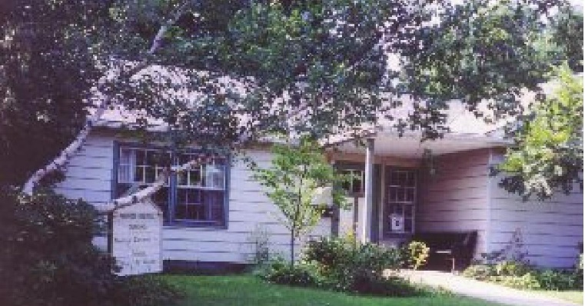

[little tree]
By E. E. Cummings

Calendar

This Month:
Dec. 18, Seasonal Celebration, 5 p.m. Dec. 25, Meeting for Worship, 11 a.m.
Future:

Jan. 1, Meeting for Worship, 11 a.m.
Jan. 8, Meeting for worship with a concern for business, 9 a.m, Meeting for Worship, 11 a.m.

Newsletter Deadline
The deadline for the next newsletter is Jan. 12 at 4 PM. This is a Thursday deadline.
Send your news to danielhazelton@rcn.com.
little tree
little silent Christmas tree you are so little
you are more like a flower

who found you in the green forest
and were you very sorry to come away? see i will comfort you
because you smell so sweetly

i will kiss your cool bark and hug you safe and tight just as your mother would, only don’t be afraid

look the spangles
that sleep all the year in a dark box
dreaming of being taken out and allowed to shine, the balls the chains red and gold the fluffy threads,

put up your little arms
and i’ll give them all to you to hold. every finger shall have its ring
and there won’t be a single place dark or unhappy

then when you’re quite dressed
you’ll stand in the window for everyone to see and how they’ll stare!
oh but you’ll be very proud

and my little sister and i will take hands and looking up at our beautiful tree we’ll dance and sing
“Noel Noel”

AQM Enabling Fund and AQM Fund Assistance

The Abington Quarterly Meeting has determined that for Unami Friends who are members or who are active attenders who may be needing short term financial assistance during this difficult time, funds are available from the Abington Quarter Meeting Enabling Fund for all members and from the AQM Fund for all active attenders.

For more information contact:
Rebecca Cratin, the Administrator of the Home and Care Committee, 215-542-8738
rhcratin@cratin.com or
Marietta Quinby, representative from Unami to the Home and Care Committee 215-257-4895
rmquinby@verizon.net

or
Lynn Biddle, Unami’s Care of Members Committee clerk
267-377-6560
lcbiddle@hotmail.com

Query for the Month of December
Deepening Our Faith: Meeting for Business

Is our meeting for business held in worship in which we seek divine guidance?
- How do we sustain prayerful consideration of all aspects of an issue and address difficult problems with a search for truth that is unhurried by the pressures of time?
- Do we recognize that we speak through our inaction as well as our action?
- Do I regularly attend meeting for business? If unable to attend, how do I fulfill the responsibility to understand and embrace the decisions made?
- How do I affirm and support God’s presence in the process of discernment and reaching a decision?
- Do I remain open to personal transformation as the community arrives at the sense of the meeting?

Unami Monthly Meeting Events December 2022

December 18, 5:00pm - Seasonal Celebration

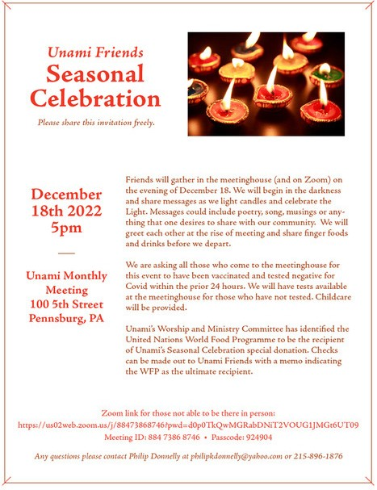

Unami Meeting for Worship, Discussion, and Meeting for Worship with a Concern for Business

We’re open, again!

With joy and thanksgiving we open the meetinghouse to you. Out of respect for those vulnerable among us to a COVID infection or ineligible to receive a vaccination at this time, we require masks to be worn at the beginning of all meetings at the meetinghouse (except toddlers and babies). If you’ve forgotten your mask, please help yourself to one on the foyer table. After the start of the meeting the convenor will ask if any of the attendees are uncomfortable with masks being removed. If all are comfortable then masks may optionally be removed during the meet- ing.

In the meetinghouse, we are using OWL technology to provide a Zoom link to those friends wor- shiping at a distance so that we can all be in the same room of the Spirit. Sit wherever you want, respecting social distance.

If you have a message, please move to the seat with a print scarf draped over it so that the OWL can pick up your message and broadcast it. Feel free to remove your mask in order to be heard clearly; thank you for replacing it after you speak.

At close of meeting before the pandemic, our tradition has been to shake hands and some to hug. At present, some of us bow and greet each other at a distance, some elbow bump. Please do what you feel is safe for you and expect that however clumsily we greet each other at close, we are nevertheless expressing peace and goodwill. We will routinely introduce ourselves so that all on Zoom or in the meetinghouse can be one gathered community.

We will have a program for children on the third and fourth Sundays of each month. Please contact First Day School committee member Linda Weinberger if you plan to bring your chil- dren at any other time. Your children are welcome in the meeting room for the first 15 minutes of worship as you choose. After that, someone will rise to usher them out for activities indoors or outside.

Meeting for Worship with a Concern for Business begins in hybrid form is on every second Sun- day at 9 a.m., followed by Meeting for Worship at the usual time: 11:00 a.m.

Please contact us at unamifriendsmeeting@gmail.com if you would like to join us by Zoom.

