October 14, 2022
Unami Monthly Meeting 100 East Fifth Street Pennsburg, PA 18073

Unami Monthly Meeting
of the Religious Society of Friends

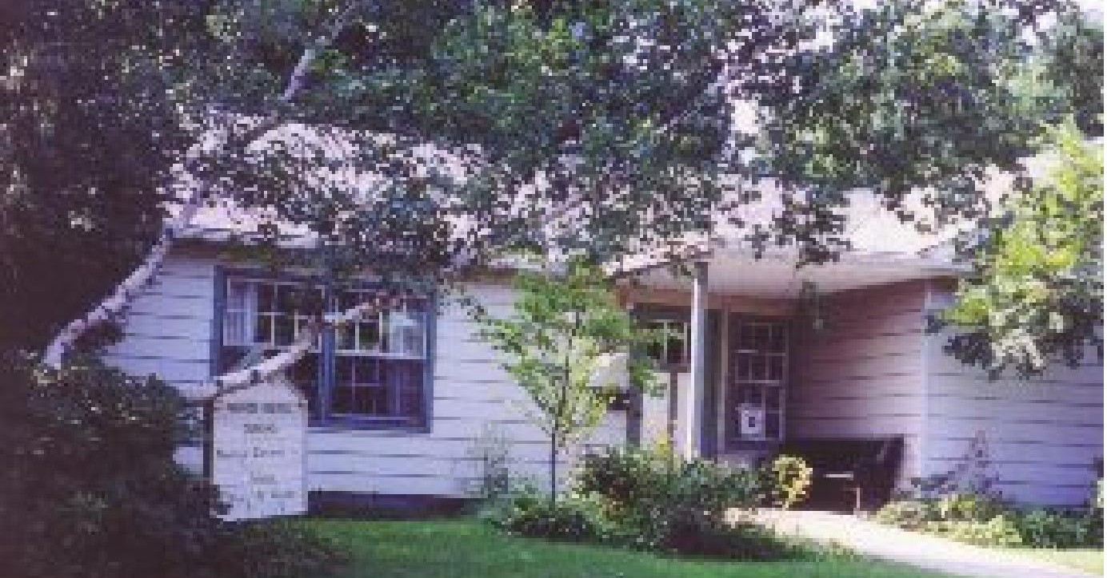Calendar
This Month:

Oct. 16, Meeting for Worship, 11 a.m.

Oct. 23, The Struggles and Joys of Trans Youth,9:30 a.m. -10:30 a.m., Meeting for Worship, 11 a.m.

October 30, Tradition of Sharing Twilight Thoughts, 9:30 a.m. -10:30 a.m., Meeting for Worship, 11 a.m.

Future:
Nov. 13, Meeting for worship with a concern for business, 9 a.m, Meeting for Worship, 11 a.m.

November 20, Reunion of Unami Friends, 12:30 p.m.

Newsletter Deadline
The deadline for the next newsletter is Nov. 17 at 4 PM. This is a Thursday deadline.
Send your news to danielhazelton@rcn.com.

The Road Not Taken
By Robert Frost

Two roads diverged in a yellow wood, And sorry I could not travel both
And be one traveler, long I stood
And looked down one as far as I could To where it bent in the undergrowth;

Then took the other, as just as fair, And having perhaps the better claim,
Because it was grassy and wanted wear; Though as for that the passing there Had worn them really about the same,

And both that morning equally lay In leaves no step had trodden black. Oh, I kept the first for another day!
Yet knowing how way leads on to way, I doubted if I should ever come back.

I shall be telling this with a sigh Somewhere ages and ages hence:
Two roads diverged in a wood, and I— I took the one less traveled by,
And that has made all the difference.

AQM Enabling Fund and AQM Fund Assistance

The Abington Quarterly Meeting has determined that for Unami Friends who are members or who are active attenders who may be needing short term financial assistance during this difficult time, funds are available from the Abington Quarter Meeting Enabling Fund for all members and from the AQM Fund for all active attenders.

For more information contact:
Rebecca Cratin, the Administrator of the Home and Care Committee, 215-542-8738
rhcratin@cratin.com or
Marietta Quinby, representative from Unami to the Home and Care Committee 215-257-4895
rmquinby@verizon.net
or
Lynn Biddle, Unami’s Care of Members Committee clerk
267-377-6560
lcbiddle@hotmail.com

Query for the Month of October
Witnessing in the World: Witness and Civic Responsibility
- What is our meeting doing:
- To become aware of systemic legal, economic and political injustices in our local community?
- To build relationships with other faith communities around common concerns?
- To reduce polarization within the larger community?
- To work together with others to address injustice?
- How does our meeting assist in restoring public recognition that government fulfills legitimate functions?
- Am I mindful of how my lifestyle, work-life and investments affect others?
- Am I open to seeking clearness on matters of conscience? Am I open to assisting others in doing so?
- Do I fulfill my civic responsibilities when they do not conflict with divine leading?

Unami Monthly Meeting Events October - November 2022

October 23, 9:30am - 10:45 a.m. The Struggles and Joys of Trans* Youth, led by Max Probst and Rae Davis. Childcare will be provided.

Join us in an engaging dialogue about the struggles and joys of being young and trans*. Young people from our local community will share their experiences and we will discuss the sociological ramifications of current legislation that targets trans* people in schools, in sports, and society in general. From banning books to “Don’t Say Gay” (and whatever else comes up between now and then), join us in conversation about the state of affairs for trans* people.

*trans is used here as an inclusive term for our transgender and gender diverse population that includes a diverse range of identities

Max Probst has been teaching Sociology at Bucks County Community College since 2009. He has served as the faculty advisor to the Open Door Club (the College’s LGBTQ+ student organization) where he has worked closely with students to bring advocacy, community, and resources to the college. Max looks forward to teaching the recently developed course, “Introduction to Queer Studies” in Spring 2023.

Rae Davis (they/them) is an educator, activist, and record-loving friend to all LGBTQ+ youth, Rae is a Community Health Educator and the founder and director of Roy G. Biv Doylestown & facilitator for the Rainbow Room Doylestown. Rae started Roy G. Biv Doylestown while working at Siren Records to fulfill the need for LGBTQ+ youth ages 10-14 to have an environment that fosters creativity, support, and education amongst like-minded kiddos.

October 30, 9:30am – Discussion led by Joyce Moore and Philip Donnelly on the history, challenges, and opportunities of Unami Meeting’s tradition of sharing “Twilight” thoughts at the rise of meeting. The discussion will include consideration of how Friends discern if they offer a vocal message during meeting for worship.

November 20, 12:30pm (note the time is to allow for Friends from afar to join us!) - Reunion of Unami Friends to remember the birth of Unami Meeting 50 years ago. Plans are still developing, and we encourage all who read this to help spread the word and offer invitations to those who have been a part of Unami’s community.

December 4, 9:30am - Revisiting our relationship with the Peace Testimony in light of the state of the world around us. More details on the format for this discussion will be forthcoming.

December 18, 5:00pm - Seasonal Celebration

First Day School Check-in

Hello Unami!

I will be coordinating the details of First Day School now that LInda and Don Weinberger are off travelling.

We will be moving to a slightly different structure for how the committee operates and also how Unami offers FDS, more details to follow at the next meeting for business.

In the meantime we’d like to extend the invitation to more Unamiians to help with the facilitation of FDS. Right now both rooms are cleaned and full of project materials.
The kids, when they come, are happy to spend time with one another and in an environment different than their home, with other families and with different adults to pay attention to them.

Signing up to help with FDS can be as simple as reading a book with the kids (or several) and talking about it, then giving them time to do projects, play, and eat
a snack. The outdoor spaces at Unami are also great, and the sandbox/ toys are ready to go. We don’t want facilitators to feel as if they need a huge lesson planned out, but more to be ready to be present and engaged with the kids in our two great classrooms, or our great yard.

Getting PA clearances (https://www.dhs.pa.gov/KeepKidsSafe/Clearances/Pages/PA- Child-Abuse-History-Clearance.aspx) and submitting to a background check is the first (basically painless) step. I am happy to be a support person to members wanting to go through that process. PYM (https://www.pym.org/youth-programs/friends-who-care-for- youth/child-safety-forms/) also has lots of resources for this as well.

We have a new sign-up genius (https://www.signupgenius.com/go/70a094da8a72da3fe3- first) for the coming fall season with spots for an older kids facilitator and younger kids facilitators. We would like to have one person available per room going forward to be able to make meeting more available to families in the event that they show up.

If you are able to get cleared and hang out with kids, we’d love to expand our net of facilitators!

Many Thanks-
Becca Munro rerebecca@gmail.com

First Day School Volunteer Guidelines

If you plan on volunteering for First Day School, in any capacity, which we hope you will, PAstate law requires copies of THREE (3) clearances and background checks on file. Please seethe links below for each clearance.

- Child Welfare - https://www.compass.state.pa.us/cwis/public/home
Create an individual account and make sure that you specify that you are a volunteer. This one can take minutes to a few days to give you results. They will email the results to you.

- State Police - https://epatch.state.pa.us/Home.jsp
Click New Record Check (yellow button). This one will give you results immediately. After you complete the form, you will see a page that has some of your information on it and a blue link to a certification form. (It’s not very clear that it is a link, but it is.)
Click that link and print the form. (There should be a watermark of the keystone shape in the background)

- PA Resident Disclosure Form (for those who have lived in PA in the last 10 years) If you have lived in PA in the past 10 years, you may complete and return this form.

https://www.dhs.pa.gov/KeepKidsSafe/Resources/Documents/Disclosure%20 Statement%20for%20Volunteers.pdf

OR
3) FBI Fingerprinting - https://www.identogo.com/
Only necessary if you’ve lived outside of PA sometime in the past 10 years. This one takes a while for results. You’ll have to register for an ID number, then find the nearest fingerprinting location and make an appointment
to get your fingerprints taken. Go to the website above, click Get Fingerprinted, select Pennsylvania, click Digital Fingerprinting, enter this service code: 1KG6ZJ , schedule an appointment, then follow the steps to fill out the form.

If you are having any trouble at all or if you would like to schedule a time to do this together, please contact

Nancy Donnelly 215-896-2523
nadonnelly@gmail.com

Unami Meeting for Worship, Discussion, and Meeting for Worship with a Concern for Business

We’re open, again!

With joy and thanksgiving we open the meetinghouse to you. Out of respect for those vulnerable among us to a COVID infection or ineligible to receive a vaccination at this time, we require masks to be worn at the beginning of all meetings at the meetinghouse (except toddlers and babies). If you’ve forgotten your mask, please help yourself to one on the foyer table. After the start of the meeting the convenor will ask if any of the attendees are uncomfortable with masks being removed. If all are comfortable then masks may optionally be removed during the meet- ing.

In the meetinghouse, we are using OWL technology to provide a Zoom link to those friends wor- shiping at a distance so that we can all be in the same room of the Spirit. Sit wherever you want, respecting social distance.

If you have a message, please move to the seat with a print scarf draped over it so that the OWL can pick up your message and broadcast it. Feel free to remove your mask in order to be heard clearly; thank you for replacing it after you speak.

At close of meeting before the pandemic, our tradition has been to shake hands and some to hug. At present, some of us bow and greet each other at a distance, some elbow bump. Please do what you feel is safe for you and expect that however clumsily we greet each other at close, we are nevertheless expressing peace and goodwill. We will routinely introduce ourselves so that all on Zoom or in the meetinghouse can be one gathered community.

We will have a program for children on the third and fourth Sundays of each month. Please contact First Day School committee member Linda Weinberger if you plan to bring your chil- dren at any other time. Your children are welcome in the meeting room for the first 15 minutes of worship as you choose. After that, someone will rise to usher them out for activities indoors or outside.

Meeting for Worship with a Concern for Business begins in hybrid form on every second Sunday at 9 a.m., starting again in September, followed by Meeting for Worship at the usual time: 11:00 a.m.

If you would like to join us by Zoom, please contact us at unamifriendsmeeting@gmail.com

